February 22, 2026

Welcome to our Guests
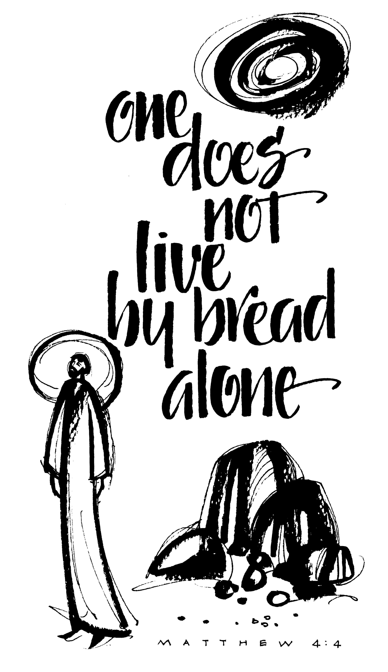
Thanks for joining us! We are gathered here to be strengthened in the faith through the Word of Jesus, the Son of God, who came to forgive and save us. If there is anything we can do to better serve you, please let us know.

ST. LUKE’S EV. LUTHERAN CHURCH (WELS), Pickwick, MN
Church (507) 454-1380 Parsonage (262) 652-7215
24799 Trout Street 39246 Mill Street
Winona, MN 55987 Winona, MN 55987
Website: stlukespickwickwels.com / Email: stlukespickwick@outlook.com

Pastor: Steven L. Neumann Musicians
Cell Phone #: (262) 308-7666 Connie Hagedorn
Email: pastorsneumann@outlook.com Kris Swogger
1st Sunday of Lent
Theme: Our God Gives Us Exactly What We Need: A Champion!

Opening Hymn: #378 All Mankind Fell in Adam’s Fall, v. 1-6

Service of The Word (found on p. 38 of our Red Hymnal)
(please stand)
Invocation
M: The grace of our Lord Jesus Christ and the love of God and the fellowship of the Holy Spirit be with you.
C: And also with you.
Confession of Sins
M: We have come into the presence of God, who created us to love and serve him as his dear children. But we have disobeyed him and deserve only his wrath and punishment. Therefore, let us confess our sins to him and plead for his mercy.
C: Merciful Father in heaven, I am altogether sinful from birth. In countless ways I have sinned against you and do not deserve to be called your child. But trusting in Jesus, my Savior, I pray: Have mercy on me according to your unfailing love. Cleanse me from my sin, and take away my guilt.

M: God our heavenly Father, has forgiven all your sins. By the perfect life and innocent death of our Lord Jesus Christ, he has removed your guilt forever. You are his own dear child. May God give you strength to live according to his will.
C: Amen.
Prayer and Praise
M: In the peace of forgiveness, let us praise the Lord.

Oh, Taste and See
C (sung ♫): Oh, taste and see that the Lord is good. Blessed are they who take refuge in him. Your Word, O Lord is eternal; It stands firm in the heavens. Your faithfulness continues forever. Oh, taste and see that the Lord is good. Blessed are they who take refuge in him.
Prayer of the Day
M: Let us pray. / Mighty God and Father, our Lord Jesus walked into the wilderness to face the devil’s temptations, but he did not succumb to Satan’s lies or falter in his resolve to save the world from the prison of hell. Bolster our faith by his mighty victory that we may battle against the forces of evil with courage and confidence; through your Son, Jesus Christ our Lord, who lives and reigns with you and the Holy Spirit, one God, now and forever.
C (♫): Amen.

(please be seated)

THE WORD

Old Testament Lesson - Genesis 3:1-15
Now the serpent was more crafty than any of the wild animals the Lord God had made. He said to the woman, “Did God really say, ‘You must not eat from any tree in the garden’?” The woman said to the serpent, “We may eat fruit from the trees in the garden, but God did say, ‘You must not eat fruit from the tree that is in the middle of the garden, and you must not touch it, or you will die.” “You will not certainly die,” the serpent said to the woman. “For God knows that when you eat from it your eyes will be opened, and you will be like God, knowing good and evil.” When the woman saw that the fruit of the tree was good for food and pleasing to the eye, and also desirable for gaining wisdom, she took some and ate it. She also gave some to her husband, who was with her, and he ate it. Then the eyes of both of them were opened, and they realized they were naked; so they sewed fig leaves together and made coverings for themselves.
Then the man and his wife heard the sound of the Lord God as he was walking in the garden in the cool of the day, and they hid from the Lord God among the trees of the garden. But the Lord God called to the man, “Where are you?” He answered, “I heard you in the garden, and I was afraid because I was naked; so I hid.” And he said, “Who told you that you were naked? Have you eaten from the tree that I commanded you not to eat from?” The man said, “The woman you put here with me—she gave me some fruit from the tree, and I ate it.” Then the Lord God said to the woman, “What is this you have done?” The woman said, “The serpent deceived me, and I ate.”
So the Lord God said to the serpent, “Because you have done this, ”Cursed are you above all livestock and all wild animals! You will crawl on your belly and you will eat dust all the days of your life.” And I will put enmity between you and the woman, and between your offspring and hers; he will crush your head, and you will strike his heel.” (NIV)

Psalm of the Day
Psalm 46 The Mighty Lord is With Us
– found on page 84 of our red hymnal, Christian Worship

Epistle Lesson - Romans 5:12–19
Therefore, just as sin entered the world through one man, and death through sin, and in this way death came to all people, because all sinned—To be sure, sin was in the world before the law was given, but sin is not charged against anyone’s account where there is no law. Nevertheless, death reigned from the time of Adam to the time of Moses, even over those who did not sin by breaking a command, as did Adam, who is a pattern of the one to come.
But the gift is not like the trespass. For if the many died by the trespass of the one man, how much more did God’s grace and the gift that came by the grace of the one man, Jesus Christ, overflow to the many! Nor can the gift of God be compared with the result of one man’s sin: The judgment followed one sin and brought condemnation, but the gift followed many trespasses and brought justification. For if, by the trespass of the one man, death reigned through that one man, how much more will those who receive God’s abundant provision of grace and of the gift of righteousness reign in life through the one man, Jesus Christ!
Consequently, just as one trespass resulted in condemnation for all people, so also one righteous act resulted in justification and life for all people. For just as through the disobedience of the one man the many were made sinners, so also through the obedience of the one man the many will be made righteous. (NIV)

(please stand)
Gospel Acclamation
M: We do not have a high priest who is unable to empathize with our weaknesses; we have one who has been tempted in every way, just as we are—yet he did not sin.

Gospel Lesson – Matthew 4:1-11 (sermon text v. 1-4)
Then Jesus was led by the Spirit into the wilderness to be tempted by the devil. After fasting 40 days and 40 nights, he was hungry. The tempter came to him and said, “If you are the Son of God, tell these stones to become bread.” Jesus answered, “It is written: ‘Man shall not live on bread alone, but on every word that comes from the mouth of God’” (Deuteronomy 8:3).
Then the devil took him to the holy city and had him stand on the highest point of the temple. “If you are the Son of God,” he said, “throw yourself down. For it is written: “‘He will command his angels concerning you, and they will lift you up in their hands, so that you will not strike your foot against a stone’” (Psalm 91:11-12). Jesus answered him, “It is also written: ‘Do not put the Lord your God to the test’” (Deuteronomy 6:16).
Again, the devil took him to a very high mountain and showed him all the kingdoms of the world and their splendor. “All this I will give you,” he said, “if you will bow down and worship me.” Jesus said to him, “Away from me, Satan! For it is written: ‘Worship the Lord your God and serve him only” (Deuteronomy 6:13).
Then the devil left him, and angels came and attended him. (NIV)

M: The Gospel of the Lord.
C (♫): Praise be to you, O Christ!

(please be seated)

Hymn of the day - #447 Who Trusts in God, a Strong Abode, v. 1-3

SERMON on Matthew 4:1-11
How to deal with the temptation to NOT TRUST God!

(please stand)
Apostles’ Creed
ALL: I believe in God the Father almighty, maker of heaven and earth.
I believe in Jesus Christ, his only Son our Lord, who was conceived by the Holy Spirit, born of the virgin Mary, suffered under Pontius Pilate, was crucified, died, and was buried. He descended into hell. The third day he rose again from the dead. He ascended into heaven and is seated at the right hand of God the Father almighty. From there he will come to judge the living and the dead.

I believe in the Holy Spirit, The holy Christian Church, The communion of saints, The forgiveness of sins, The resurrection of the body, and the life everlasting. Amen.

(please be seated)
Offering of Thanksgiving
Visitors: We are very glad you are worshiping with us today. Please don’t feel obligated to give an offering. ALL: Please greet and introduce yourself to those around you.

(please stand as the offering is brought forward)

Prayer of the Church for Lent (p. 125 in the hymnal)
M: Heavenly Father, you loved the world and gave your Son to liberate us from sin and death by his obedient death on the cross.
C: We confess that without your love we are lost.

M: Lord of the Church, we thank you for the treasure of the gospel. By your Spirit, keep our eyes fixed on Jesus, the author and perfecter of our faith.
C: Strengthen our determination to do what pleases you, no matter what the danger or the cost.

M: Let us pray for those who carry a cross in the name of Christ and face ridicule and persecution for the sake of the kingdom: missionaries and chaplains, young people who stand up for what is right in the face of pressure to do what is wrong, and all who pay a high price for their faith and their values as Christians.
C: By your Spirit, O Lord, grant them patience and endurance.

M: Let us pray for those who carry heavy burdens in life: the sick and the chronically ill, the depressed and the lonely, those torn by conflict in personal relationships, those victimized by war and injustice, and all who face the terrors of life with a heavy heart.
C: Grant them peace, O Lord, and in your mercy, be their guardian and friend, their comfort and hope.

M: Let us pray for those who care for others: pastors and counselors; physicians and nurses; social workers and caring friends; all who feed the hungry, comfort the hurting, and stand beside the dying.
C: Strengthen them in their work, O Lord, and do not let them become weary in doing good.
Special prayers and intercessions may follow.
M: Hear us, Lord, as we bring you our private petitions.
(Silent prayer)

M: Help us run with perseverance the race marked out for us. Keep us faithful even to the point of death, that we may receive the crown of life, through Jesus Christ, our Lord.
C: Amen.
The Lord’s Prayer
Our Father, who art in heaven, hallowed be thy name, thy kingdom come, thy will be done on earth as it is in heaven. Give us this day our daily bread; and forgive us our trespasses, as we forgive those who trespass against us; and lead us not into temptation,
but deliver us from evil. For thine is the kingdom, and the power, and the glory, forever and ever. Amen.
(please be seated)

Hymn #349 Jesus Priceless Treasure, v. 1-3

Closing Prayer
M: O Lord God, our heavenly Father, pour out the Holy Spirit on your faithful people. Keep us strong in your grace and truth, protect and comfort us in all temptation, and bestow on us your saving peace, through Jesus Christ, our Lord, who lives and reigns with you and the Holy Spirit, one God, now and forever.
C (♫): Amen.
Blessing
M: Brothers and sisters go in peace. Live in harmony with one another. Serve the Lord with gladness. The Lord bless you and keep you. The Lord make his face shine on you and be gracious to you. The Lord look on you with favor (+) and give you peace.
C (♫): Amen, Amen, Amen.

Closing Hymn #349 Jesus, Priceless Treasure, v. 4-5
-----------------------------------------------------------------------------------------------------
Today’s Door Offering: Native Christians

Sunday AM Bible Study: is held downstairs after the service concludes. Coffee and goodies to get you through until lunch will be provided. Today we look at:
Life’s BIG Questions – God’s TRUE Answers!
Lesson 4 – Why Do I Do What I Do?

In Our Entryway, please help yourself to:
Keurig Coffee
Meditations (devotional book), “Forward in Christ” & MLC’s “In Focus” Magazines, & copies of our Church Calendar for the month.
This Week at St. Luke’s
Thursday, February 26th: Lenten Service at 6:30 PM w/treats & fellowship after.
[Note: Midweek Lenten Services will differ from Sunday services now until Easter; & there will be no communion on Thursdays until Holy Week, April 2nd. Spend an extra hour each week “watching & praying” with Jesus, as he told his disciples in Gethsemane to do!]

Happy Birthday: Diane McNamer (Today!); Happy (Belated) Anniversary: Mark & Holli Wieser (20th).

March Church Cleaning: Patti Kelso by 3/1; Rachel Fabian by 3/8; Mary Green by 3/15; Jess McGann by 3/22.

March Ushers: Rick Rockwell, Matt Wieser, & Kurt Swogger.

March Bulletin Sponsors: Mel Dingfelder in memory of his wife, Alida Dingfelder’s birthday. Bob & Mary Green in celebration of their anniversary.

Sign-up in the Entryway to: a) volunteer to Greet & Help people at the door, and b) for an Every Member Visit with our new pastor and his wife, Niki.

Directions to our Church Directory APP – The APP is called Universal Church Directory and can be downloaded where a person gets their apps. St. Luke’s unique identifier is b6rrlCYkOO. Rebecca Church is the point of contact for help or questions about the app.
Looking Ahead:
Luther High School’s BIG KNIGHT – Their Annual Fundraiser, supporting students at LHS with tuition assistance, is Saturday, April 11th 5:30-9 PM at Celebrations on the River. Federation congregations have been asked to donate a basket(s) for their silent auction; donations can be turned in at church, NLT Easter Sunday. Questions? Contact Natalie Siok. Registration is open if you would want to attend or donate money to the event; copy the link into your browser: https://secure.qgive.com/event/bigknight2026/

Lutheran Women’s Missionary Society (LWMS) – Spring Rally will be held on Saturday, April 18th at St. Paul’s Church in Onalaska, WI. Registration & refreshments begins at 8 AM; Devotion at 9 AM; Main Guest Speaker will be Rev. Jeff Mahnke, Western District Mission Board Chairman, presenting on 100 Missions in 10 Years. There will be mission displays and a short business meeting, with lunch served about Noon. Mark your calendar to attend, ladies! Natalie Siok is POC for any LWMS questions (natalie.siok@gmail.com, 612.968.2528).
LWMS 63rd National Convention - will be held in Madison, WI June 25-28, 2026. Registration opens March 1st. Register online at 63.lwms.org. Paper registration forms and info are available on the back counter in our entryway. Natalie Siok is POC for any LWMS questions (natalie.siok@gmail.com, 612.968.2528).

WELS International Youth Rally - is July 14-17, 2026 at Bowling Green University, Bowling Green, Ohio for those in high school this fall. $450/attendee plus travel expenses. Register March 9th – April 30th; 1st come 1st served as these rallies have sold out of late. Updates are available on the WELS Facebook page. If you or someone you know would like to attend, please speak with Pastor Neumann ASAP.

St. Luke’s Ev. Lutheran Church (WELS), Pickwick, MN
Service Times: Thursdays: 6:30 PM Sundays: 9 AM w/Bible Study at 10:15 AM
Communion is celebrated on the 1st and 3rd weeks of the month.

Church Council Members
Mark Wieser, President (2nd Term – 2027), markwieser85@gmail.com, 507-312-0085
Jim Albrecht, Financial Secretary (1st Term-2027), ltcattle@acegroup.cc, 507-643-6126
Jeremy Church, Treasurer (2nd Term-2028), jeremych87@gmail.com, 507-459-0648
Tom Mueller, Secretary (1st Term-2029), tpmue@yahoo.com, 507-452-5539
Kurt Swogger, Properties (2nd Term-2028), kurtswog@yahoo.com, 507-313-0013
Dean Morgan, Properties (1st Term-2029), deanm@hbci.com, 507-450-3663

St. Luke’s Lutheran Church of Pickwick accepts the Bible as the inspired inerrant Word of God. We believe that God created the entire universe in six natural days out of nothing by his almighty Word. We believe that humankind fell into sin and is totally corrupt, dead in trespasses and sin, and doomed to hell. We believe that God out of love for us humans sent his own Son who became human, lived a perfect life in our place, and suffered eternal death for us. We believe that God the Holy Spirit uses this Gospel message in Word and Sacraments to create faith in us and thus make Jesus’ saving work ours. St. Lukes Evangelical Lutheran Church is a gathering of Christians that exists to teach and preach the Word of God in all its Truth here among us and to all the people of earth, and to worship God and serve our neighbor in love as Jesus calls us to.
We’d love to have you join us!

