June 14, 2026

Welcome to the Outdoor Service of
ST. LUKES EV. LUTHERAN CHURCH (WELS), Pickwick, MN
Website: stlukespickwickwels.com / Email: stlukespickwick@outlook.com
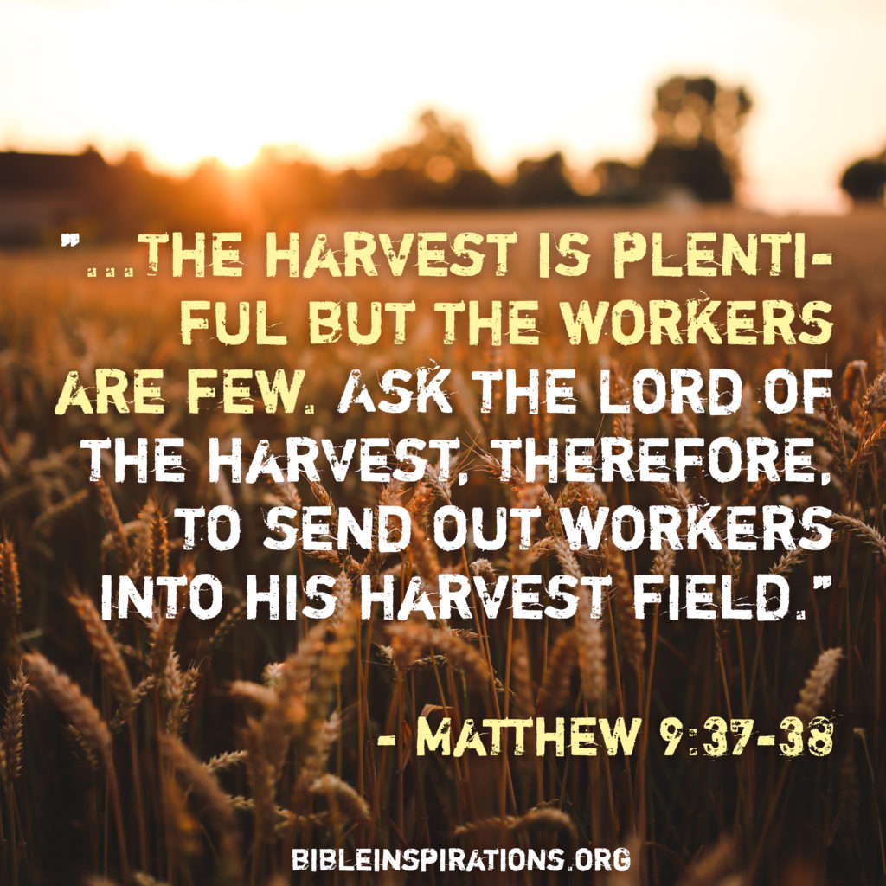

To Our Guests:
Thank you for joining us! We are gathered here to be strengthened in the faith through the Word of Jesus, the Son of God, who came to save us. If there is anything we can do to better serve you, please let us know.
3rd Sunday after Pentecost
Theme: Shout It Out-loud: Jesus Leads Us to Heaven’s Promised Land!

Opening Hymn #440 On Eagles’ Wings

1. You who dwell in the shelter of the Lord, Who abide in his shadow for life,
Say to the Lord: “My refuge, My rock in whom I trust!”
(Refrain:) And he will raise you up on eagles’ wings,
Bear you on the breath of dawn,
Make you to shine like the sun,
And hold you in the palm of his hand.

2. Snares of the fowler will never capture you, And famine will bring you no fear;
Under his wings your refuge, His faithfulness your shield. (Refrain: cf. above)

3. For to his angels he’s given a command To guard you in all of your ways;
Upon their hands they will bear you up, Lest you dash your foot against a stone.
(Refrain: cf. above)
Text: Michael Joncas, b. 1951, abr., alt. © 1979 New Dawn Music (admin. OCP Publications). All rights reserved. Used by permission.

INVOCATION
Minister: In the name of the Father and of the + Son and of the Holy Spirit.
Congregation: Amen.

CONFESSION OF SINS
M: Beloved in the Lord, since we intend to come into the presence of God, it is important for us to carefully examine ourselves using the mirror of God’s law. When we carefully look at ourselves, we discover that we have not lived as God's children ought to live. We have sinned against God in our words, thoughts, and actions, and have sinned against one another. Therefore let us confess our sins and ask for God's forgiveness for Jesus' sake. I ask you now, do you sincerely confess that you have sinned against God in your life and do not deserve His love?
C: Yes, I confess that I have sinned against God and against my brothers & sisters.

M: Do you truly believe that God, by grace, for the sake of Jesus Christ, forgives all your sins?
C: Yes, I believe that for Jesus' sake, God forgives all my sins.

M: Do you truly repent of those sins, that is, do you want God to help you by the power of His Holy Spirit, to change your life so you may live as a child of God, giving Him honor and glory in all you do?
C: Yes I ask for God's help to change my life & to empower me to live without sin.

ABSOLUTION
M: Upon this your confession, I, as a called & ordained servant of the Word, announce the grace of God to you, & in the place and by the command of our Lord Jesus Christ, I forgive all your sins in the name of the Father & of the + Son & of the Holy Spirit. / C: Amen.

PRAYER OF THE DAY
M: Almighty, eternal God, in the Word of your apostles and prophets, you have proclaimed to us your saving will. Grant us faith to believe your promises that we may receive eternal salvation; through your Son, Jesus Christ our Lord, who lives and reigns with you and the Holy Spirit, one God, now and forever.

C: Amen.
+ THE WORD OF THE DAY +

The Old Testament Lesson – Numbers 27:15-23
Moses said to the Lord, “May the Lord, the God who gives breath to all living things, appoint someone over this community to go out and come in before them, one who will lead them out and bring them in, so the Lord’s people will not be like sheep without a shepherd.” So, the Lord said to Moses, “Take Joshua son of Nun, a man in whom is the spirit of leadership, and lay your hand on him. Have him stand before Eleazar the priest and the entire assembly and commission him in their presence. Give him some of your authority so the whole Israelite community will obey him. He is to stand before Eleazar the priest, who will obtain decisions for him by inquiring of the Urim before the Lord. At his command he and the entire community of the Israelites will go out, and at his command they will come in.” Moses did as the Lord commanded him. He took Joshua and had him stand before Eleazar the priest and the whole assembly. Then he laid his hands on him and commissioned him, as the Lord instructed through Moses. (NIV)

Psalm of the Day: Psalm 103 set to music as Hymn 850 in the NEW WELS Hymnal, It Is Well With My Soul, by Wesley Pritchard & David Phelps

- When peace like a river attendeth my way, When sorrows like sea billows roll;
Whatever my lot Thou has taught me to say, It is well, it is well, with my soul.
(Refrain:) It is well, with my soul, It is well, it is well, with my soul.

- Though Satan should buffet, Though trials should come,
Let this blest assurance control,
That Christ hath regarded my helpless estate
And has shed his own blood for my soul. (Refrain: Cf. above)

- My sin - oh, the bliss of this glorious thought!
My sin, not in part but the whole,
Is nailed to the cross, and I bear it no more,
Praise the Lord, praise the Lord, O my soul! (Refrain: Cf. above)

- And Lord, haste the day when my faith shall be sight,
The clouds be rolled back as a scroll;
The trump shall resound, and the Lord shall descend,
Even so, it is well with my soul. (Refrain: Cf. above)
Songwriters: Horatio G. Spafford, Keith Getty, Philip Paul Bliss.

Epistle Lesson – 1 Corinthians 4:1-7
This, then, is how you ought to regard us: as servants of Christ and as those entrusted with the mysteries God has revealed. Now it is required that those who have been given a trust must prove faithful. I care very little if I am judged by you or by any human court; indeed, I do not even judge myself. My conscience is clear, but that does not make me innocent. It is the Lord who judges me. Therefore, judge nothing before the appointed time; wait until the Lord comes. He will bring to light what is hidden in darkness and will expose the motives of the heart. At that time each will receive their praise from God. Now, brothers and sisters, I have applied these things to myself and Apollos for your benefit, so that you may learn from us the meaning of the saying, “Do not go beyond what is written.” Then you will not be puffed up in being a follower of one of us over against the other. For who makes you different from anyone else? What do you have that you did not receive? And if you did receive it, why do you boast as though you did not? (NIV)

GOSPEL ACCLAMATION
ALL: Alleluia. Ask the Lord of the harvest to send out workers into his harvest field. Alleluia.

Gospel Lesson – Matthew 9:35-10:8 (sermon text)
Jesus went through all the towns and villages, teaching in their synagogues, proclaiming the good news of the kingdom and healing every disease and sickness. When he saw the crowds, he had compassion on them, because they were harassed and helpless, like sheep without a shepherd. Then he said to his disciples, “The harvest is plentiful but the workers are few. Ask the Lord of the harvest, therefore, to send out workers into his harvest field.” Jesus called his twelve disciples to him and gave them authority to drive out impure spirits and to heal every disease and sickness. These are the names of the twelve apostles: first, Simon (who is called Peter) and his brother Andrew; James son of Zebedee, and his brother John; Philip and Bartholomew; Thomas and Matthew the tax collector; James son of Alphaeus, and Thaddaeus; Simon the Zealot and Judas Iscariot, who betrayed him. These twelve Jesus sent out with the following instructions: “Do not go among the Gentiles or enter any town of the Samaritans. Go rather to the lost sheep of Israel. As you go, proclaim this message: ‘The Kingdom of heaven has come near.’ Heal the sick, raise the dead, cleanse those
who have leprosy, drive out demons. Freely you have received; freely give. (NIV)

SEASONAL RESPONSE

All: - Come, Holy Spirit! Fill the hearts of your faithful people; and kindle in us the fire of your love. Alleluia!

Small Group Anthem - Jesus, Ever-Abiding Friend

Hymn of the day - #492 Son of God, Eternal Savior

1. Son of God, eternal Savior, Source of life and truth and grace,
Word made flesh, whose birth among us, Honors all our human race,
You our head, who, throned in glory, For your own will ever plead:
Fill us with your love and pity; Heal our wrongs and help our need.

2. Come, O Christ, and reign among us, King of love and Prince of Peace;
Hush the storm of strife and passion; Bid its cruel discords cease.
By your patient years of toiling, By your silent hours of pain,
Quench our fevered thirst for pleasure; Stem our selfish greed for gain.

3. Bind us all as one together In your Church’s sacred fold,
Weak and healthy, poor and wealthy, Sad and joyful, young and old.
Is there want or pain or sorrow? Make us all the burden share.
Are there spirits crushed and broken? Teach us, Lord, to soothe their care.

4. As you, Lord, have lived for others, So may we for others live.
Freely have your gifts been granted; Freely may your servants give.
Yours the gold and yours the silver, Yours the wealth of land and sea;
We but stewards of your bounty Held in solemn trust will be.
Text: Somerset T. C. Lowry, 1855-1932, abr., alt.

Sermon by Pastor Steven L. Neumann on Matthew 9:35-10:8
Show Compassion to the Harassed & Helpless!

APOSTLES CREED
ALL: I believe in God the Father almighty, maker of heaven and earth.

I believe in Jesus Christ, his only Son our Lord, who was conceived by the Holy Spirit, born of the virgin Mary, suffered under Pontius Pilate, was crucified, died, and was buried. He descended into hell. The third day he rose again from the dead. He ascended into heaven and is seated at the right hand of God the Father almighty. From there he will come to judge the living and the dead.


I believe in the Holy Spirit, The holy Christian Church, The communion of saints, The forgiveness of sins, The resurrection of the body, and the life everlasting. Amen.

Offering
Visitors: We are very glad you are worshiping with us today. Please don’t feel obligated to give an offering. ALL: Please greet and introduce yourself to those worshipping around you.

PRAYER OF THE CHURCH
M: Lord Jesus, you are the gift of God the Father to this world of sin and death. You are our salvation, our hope, our peace and our joy. You bore our sin. You rose from our grave. You ascended triumphant to the skies, where you reign as Lord of the Church and as the Name above every name. Dear Lord . . .
C: For all this we adore you.

M: If we despise your Word and Sacraments; if we take for granted our congregations, our called workers, or our synod, seeing only the flaws but not recognizing the gifts; if we wring our hands with worry in the midst of abundant wealth and constant spiritual blessing; if we fail to do what we can do and give what we can give for your sake, we confess our sin. Dear Lord . . .
C: For all this we beg your mercy.

M: As we worship today, the steady voice of forgiveness reaches our ears through the public ministry you provide. What assurance we have, what unity in faith - what constancy in doctrine and truth! These come through the workers you equip and call to serve us in gospel ministry. Dear Lord . . .
C: For all this we thank you.

M: As false teaching and deceptive ideas assault your church from every side; as shallow stewardship, sinful pride, and shameful complacency threaten the church from within, we need leaders who faithfully follow you. We ask you to preserve in our midst a system of worker training that is faithful to your Word. Dear Lord . . .
C: For all this we depend upon you.

M: To remain ever one in faith, to shine like stars in this darkening world, to faithfully carry whatever crosses you send, to be moved by your grace and renewed in the joy of salvation—these are our profound desires. Dear Lord . . .
C: Grant us your Holy Spirit that we may love the One who loved us first and best.

M: In your name your people pray.
C: In your name we say: Amen.
LORD’S PRAYER
C: Our Father, who art in heaven, hallowed be thy name, thy kingdom come, thy will be done on earth as it is in heaven. Give us this day our daily bread; and forgive us our trespasses, as we forgive those who trespass against us; and lead us not into temptation, but deliver us from evil. For thine is the kingdom and the power and the glory forever and ever. Amen.

BLESSING
M: Brothers and sisters, go in peace. Live in Harmony with one another. Serve the Lord with gladness. The Lord bless you and keep you. The Lord make his face shine on you and be gracious to you. The Lord look on you with favor (+) and give you peace.
C: Amen.

Closing Hymn #451 Precious Lord, Take My Hand

1. Precious Lord, take my hand, Lead me on, let me stand;
I am tired, I am weak, I am worn.
Through the storm, through the night, Lead me on to the light.
Take my hand, precious Lord; Lead me home.

2. When my way grows drear, Precious Lord, linger near,
When my life is almost gone,
Hear my cry, hear my call; Hold my hand lest I fall.
Take my hand, precious Lord; Lead me home.

3. When the darkness appears And the night draws near
And the day is almost gone,
At the river I stand; Guide my feet, hold my hand,
Take my hand, precious Lord; Lead me home.
Text: Thomas A. Dorsey, 1899-1993, alt. © 1938 Unichappell Music, Inc. Renewed 1965 (admin. by Alfred Publishing Co.).
All rights reserved. Used by permission.
-----------------------------------------------------------------------------------------------------------------
A FREE Brunch Fellowship follows today’s service! All are invited to join in!

This Week at St. Luke’s
TODAY Farewell for Threlkeld’s at Grace Ridgeway, 1-4 PM.
Monday Church Council 6 PM (at church)
Wednesday New Bible Study begins at 6:30PM (Will the Real Jesus please stand up?)
Thursday Men’s Breakfast Bible Study at Perkins 7 AM.
Worship Service with communion, at 6:30 PM.
Happy Birthday: Mitch Meyerhoff & Tom Volkman (TODAY!);
Connie Hagedorn (Belated 6/9)
Happy Anniversary: Tom & Laurie Church; Sam & Becky Aldinger (6/15)
Jay & Kim Hansen (Belated – 6/9)
June Church Cleaning: Tara Suffrins by 6/14; Dawn Suffrins by 6/21; Amy Woodard by 6/28.
June Ushers: Bill Suffrins, Bob Malenke, & (council member) Jim Albrecht.
June Bulletin Sponsors: Gene, Rob, & Rick Betsinger in memory of Lorna Betsinger for her and Gene’s wedding anniversary.
Looking Ahead
Monthly Activities: See sign-up sheets on back counter inside the church for a La Crosse Logger’s Baseball game 6/27/2026 and a Boat Trip to Sullivan’s Restaurant 7/26/2026.
To Celebrate America’s 250th Anniversary: we will have a special service on Sunday, July 5th at 9am; after service we will have a special fellowship time with special goodies (apple pie included, of course). A sign-up sheet will be available for pies (especially, apple pies) for fellowship after the service. Since this will be a “Bring a Friend” Sunday, start thinking of who you can invite to join this celebration!
Opportunity to Serve: WELS Camp Whitewater desperately needs volunteers (weeks of July 12th -17th and July 19th-24th). They need teen & adult helpers both weeks. Talk with Nick Wieser who is on the camp board for more specifics or let Pastor Threlkeld know if you can help (pastorthrelkeld@gmail.com) or by phone at 414-943-4461.

Pastor Steven Neumann’s Contact Information Musicians
Cell Phone #: (262) 308-7666 Connie Hagedorn
Email: pastorsneumann@outlook.com Kris Swogger

Church Council Members
Mark Wieser, President (2nd Term – 2027), markwieser85@gmail.com , 507-312-0085
Jim Albrecht, Financial Secretary (1st Term – 2027), ltcattle@acegroup.cc , 507-643-6126
Jeremy Church, Treasurer (2nd Term – 2028), jeremych87@gmail.com , 507-459-0648
Tom Mueller, Secretary (1st Term – 2029), tpmue@yahoo.com , 507-452-5539
Kurt Swogger, Properties (2nd Term – 2028), kurtswog@yahoo.com , 507-313-0013
Dean Morgan, Properties (1st Term – 2029), deanm@hbci.com , 507-450-3663
Elders
Tim Albrecht (talbrech@acegroup.cc/507.459.2722),
Alex Ellinghuyusen are1976@gmail.com / 507.429.0321
Scott Fabian scottfabian21@gmail.com/507.458.2442)
Bud Krause (lckjak1@gmail.com/507.454.6938

If you or someone you know might be interested in joining our congregation, Pastor offers a NO COST / NO OBLIGATION class that goes over the main doctrines of the Christian faith which also serves as Preparation to take the Lord’s Supper & as a New Member Class, if the person is so interested. Speak with Pastor for specifics.

