September 13, 2026
ST. LUKE’S EV. LUTHERAN CHURCH (WELS) 24799 Trout Street, Pickwick, MN 55987
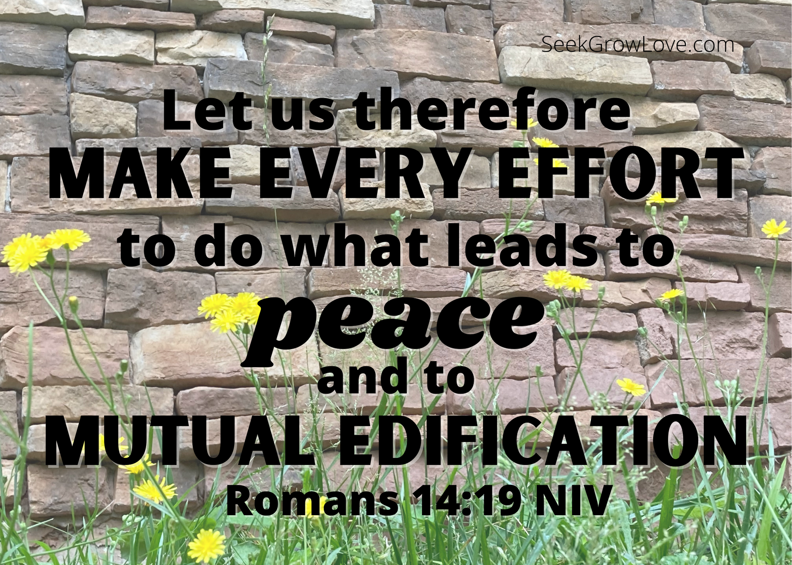
Website: stlukespickwickwels.com / Email: stlukespickwick@outlook.com
Welcome Guests!
Thank you for joining us! We are gathered here to be strengthened in the faith through the Word of Jesus, the Son of God, who has come to forgive and save us all. If there is anything we can do to better serve you, please let us know.
Pastor Steven Neumann’s Contact Info Lead Musicians
Cell Phone #: (262) 308-7666 Connie Hagedorn
Email: pastorsneumann@outlook.com Kris Swogger

16th Sunday after Pentecost
Theme: Unexpected Truth: Forgiveness & Loving Respect is for ALL!

Gathering Rite on the Word of God
(please stand)

[Please follow this order of service in the Blue Supplement in each pew
beginning on Page 11, or on the PowerPoint Slides.]

Prayer of the Day
M: Let us pray. / Lord God, heavenly Father, you graciously forgive us all our sins and abundantly provide for all our needs of body and soul. Give us confidence in your mercy, and teach us also to be merciful to our neighbor, that we willingly forgive all people, and judging only ourselves, lead blessed lives to your glory; through your Son, Jesus Christ our Lord, who lives and reigns with you and the Holy Spirit, one God, now and forever. / C: Amen. (please be seated)

+ THE WORD OF THE DAY +


Old Testament Lesson – Genesis 50:15-21
When Joseph’s brothers saw that their father was dead, they said, “What if Joseph holds a grudge against us and pays us back for all the wrongs we did to him?” So they sent word to Joseph, saying, “Your father left these instructions before he died: ‘This is what you are to say to Joseph: I ask you to forgive your brothers the sins and the wrongs they committed in treating you so badly.’ Now please forgive the sins of the servants of the God of your father.” When their message came to him, Joseph wept. His brothers then came and threw themselves down before him. “We are your slaves,” they said. But Joseph said to them, “Don’t be afraid. Am I in the place of God? You intended to harm me, but God intended it for good to accomplish what is now being done, the saving of many lives. So then, don’t be afraid. I will provide for you and your children.” And he reassured them and spoke kindly to them. (NIV)

Psalm of the Day - Psalm 103: I will hear what the Lord proclaims (found on page 105 at the front of our red hymnal, Christian Worship)

Epistle Lesson – Romans 14:5-10, 13, 19 (sermon text)
One person considers one day more sacred than another; another considers every day alike. Each of them should be fully convinced in their own mind. Whoever regards one day as special does so to the Lord. Whoever eats meat does so to the Lord, for they give thanks to God; and whoever abstains does so to the Lord and gives thanks to God. For none of us lives for ourselves alone, and none of us dies for ourselves alone. If we live, we live for the Lord; and if we die, we die for the Lord. So, whether we live or die, we belong to the Lord. For this very reason, Christ died and returned to life so that he might be the Lord of both the dead and the living. You, then, why do you judge your brother or sister? Or why do you treat them with contempt? For we will all stand before God’s judgment seat. Therefore, let us stop passing judgment on one another. Instead, make up your mind not to put any stumbling block or obstacle in the way of a brother or sister. Let us therefore make every effort to do what leads to peace and to mutual edification. (NIV) (please stand)

Gospel Acclamation
C: Alleluia. Bear with each other and forgive one another. Forgive as the Lord forgave you. Alleluia.

Gospel Lesson – Matthew 18:21-35
Then Peter came to Jesus and asked, “Lord, how many times shall I forgive my brother or sister who sins against me? Up to seven times?” Jesus answered, “I tell you, not seven times, but seventy-seven times. “Therefore, the kingdom of heaven is like a king who wanted to settle accounts with his servants. As he began the settlement, a man who owed him ten thousand bags of gold was brought to him. Since he was not able to pay, the master ordered that he and his wife and his children and all that he had be sold to repay the debt. “At this the servant fell on his knees before him. ‘Be patient with me,’ he begged, ‘and I will pay back everything.’ The servant’s master took pity on him, canceled the debt and let him go.
“But when that servant went out, he found one of his fellow servants who owed him a hundred silver coins. He grabbed him and began to choke him. ‘Pay back what you owe me!’ he demanded. “His fellow servant fell to his knees and begged him, ‘Be patient with me, and I will pay it back.’ “But he refused. Instead, he went off and had the man thrown into prison until he could pay the debt. When the other servants saw what had happened, they were outraged and went and told their master everything that had happened.
“Then the master called the servant in. ‘You wicked servant,’ he said, ‘I canceled all that debt of yours because you begged me to. Shouldn’t you have had mercy on your fellow servant just as I had on you?’ In anger his master handed him over to the jailers to be tortured, until he should pay back all he owed. “This is how my heavenly Father will treat each of you unless you forgive your brother or sister from your heart.” (NIV) / M: The Gospel of the Lord. (please be seated)

Hymn of the Day: #773 (in the Blue Supplement), In Unity and Peace [Our Small Group sings the initial Refrain & the verses, the congregation is invited to join in on the subsequent Refrains.]

SERMON by Pastor Neumann on Romans 14:5-10, 13, 19
Protect Our Unity by Respecting Each Other’s Christian Freedoms!
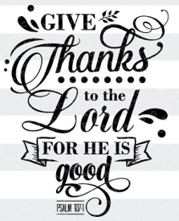
Confession of Faith - 3rd Article of the Apostles’ Creed with Luther’s explanation

I believe in the Holy Spirit; the Holy Christian church, the communion of saints, the forgiveness of sins, the resurrection of the body, & the life everlasting. Amen.

What does this mean?

I believe that I cannot by my own thinking or choosing believe in Jesus Christ, my Lord, or come to Him. But the Holy Spirit has called me by the gospel, enlightened me with His gifts, sanctified & kept me in the true faith. In the same way He calls, gathers, enlightens, & sanctifies the whole Christian church on earth, & keeps it with Jesus Christ in the one true faith.
In this Christian church He daily & fully forgives all sins to me & all believers. On the Last Day He will raise me & all the dead, & give eternal life to me & all believers in Christ. This is most certainly true.
Offering of Thanksgiving
Visitors: We are very glad you are worshiping with us today. Please don’t feel obligated to give an offering. ALL: Please greet and introduce yourself to those around you.
Prayer of the Church
By Pastor

The Lord’s Prayer
Our Father, who art in heaven, hallowed be thy name, thy kingdom come, thy will be done on earth as it is in heaven. Give us this day our daily bread; and forgive us our trespasses, as we forgive those who trespass against us; and lead us not into temptation, but deliver us from evil. For thine is the kingdom, and the power, and the glory, forever and ever. Amen.

Sermon Hymn: God Loves Me Dearly (#583 from CW 21)

1. God loves me dearly, Grants me salvation,
God loves me dearly, Loves even me.
(Refrain:) Therefore I'll say again: God loves me dearly,
God loves me dearly, loves even me.

2. I was in slav'ry, Sin, death, and darkness;
God's love was working To make me free. [Refrain: cf. above]

3. He sent forth Jesus, My dear Redeemer,
He sent forth Jesus And set me free. [Refrain: cf. above]

4. Jesus, my Savior, Himself did offer;
Jesus, my Savior, Paid all I owed. [Refrain: cf. above]

5. Now I will praise you, O Love eternal;
I will praise you All my life long. [Refrain: cf. above]

Closing Prayer
M: Lord of the harvest, give to Your Church a continual stream of men and women eager to volunteer and prepare for service in Your kingdom, especially as teachers of Your Word to young and old alike. Bless our opportunities for all to grow in faith and knowledge of Your Word here at St. Luke’s. Bless all of the Sunday Schools and parochial schools of our area, and throughout our church body with instructors who encourage and inspire their students to grow in real grace and wisdom: Your Word. Help all students there to hear, understand, love, and live Your truths. Strengthen the resolve of all the young people currently at our worker training schools to complete their training for ministry; and then send them out in the power of Your Spirit as a continued blessing into Your harvest fields. We ask this all in Jesus’ precious name.
C: Amen.
Blessing
M: The LORD bless you and keep you. The LORD make his face shine on you and be gracious to you. The LORD look on you with favor (+) and give you peace.
C: Amen.

Closing Hymn #458 May We Your Precepts, Lord, Fulfill, v. 1-3
Today’s Door Offering: Friends Network

Bible Study: Please join us downstairs after today’s service for coffee & goodies & a NEW study, as we delve into 1 Corinthians & learn from ‘A Congregation in Crisis’.

This Week at St. Luke’s
Monday: Church Council 6 PM (at the parsonage);
Women’s New Fall Bible Study downstairs at 6:30 PM.
Wednesday: Bible Study 6:30 PM; Book is “Connecting Sinai to Calvary”
Thursday: Men’s Bible Study at Perkins, 7AM;
Worship service with communion 6:30PM.
Saturday: Decorate Float for Sunday’s Apple Fest Parade, 2 PM @ Jim Albrecht’s
Sunday: Apple Fest Parade in La Crescent MN, 1 PM.

Happy Birthday: Renee Larsen (Today!); Jim Larson, Denise Albrecht (14th),
Sue McNally (16th) / Happy Anniversary: Scott & Barb Fabian.

Sept. Cleaning: Kim Rockwell by 9/13; Kris Swogger by 9/20; Jess McCann by 9/27/2026.
September Ushers: Scott Fabian, Wayne Albrecht, & Kurt Swogger.
September Bulletin Sponsors: Marvin & Mary Jo Mades (47th) and Al & Natalie Siok (48^{th)} Anniversary; Denny & Debi Allen and Bill & Tara Suffrins in memory of Dean Suffrins’ Birthday.
Looking Ahead:
Winona Area 20 & 30’s Group: is gathering at Suncrest Pizza Farm (S2257 Yaeger Valley Road, Cochrane, WI) for an evening of fellowship, friends, fun & PIZZA on Friday, September 18th. Either meet at Suncrest Gardens Pizza Farm at 6pm or meet at St. Matthew's at 5:30pm to carpool. Bring your own lawn chairs and $7 to contribute towards pizza. A playground, farm animals, and pick your own flowers are at the location; so, feel free to bring along your children. Please RSVP to Savannah Kubis - 507-429-3316 (text) or savannahkubis@gmail.com if you plan to attend so we can anticipate how many pizzas to order.

Mission Festival: A special 9am Mission Service will be held on Sunday, September 27th with a FREE lunch afterwards. Pastor Mark Wegner of WELS 316NOW (which carries out mission work in SE Asia) will preach and present. Make plans to join us for this special day and bring a friend!

Retreats: Check out the power point for 2 WELS Women’s Retreats & 2 Men’s Retreats upcoming this fall and consider these opportunities for growth & fellowship.
Family Bible Study: Join us on Wednesday September 30th at 6pm for this fun evening of food, fellowship, and having our faith fed! This study takes place at Kurt and Kris Swogger’s home (23371 Lamoille Rd.). We begin with a meal together (the main dish is provided – please bring a dish to share if possible), and then after supper we move into our bible study: Idols We Never Knew We Had. This fall session meets every other Wednesday 4 times starting September 30th. Join us!

WELS Military Retreat: will be held October 8-11 at Ironwood Springs Christian Ranch near Rochester, MN. This event is for active military members & veterans, and their spouses. Learn more or register at www.lutheranmilitary.org.

St. Lukes Ev. Lutheran Church (WELS), Pickwick MN

Service Times: Thursdays: 6:30PM Sundays: 9AM with Bible Study at 10:15AM
Communion is normally celebrated the 1st & 3rd weeks of the month

Church (507) 454-1380 Parsonage (262) 652-7215
24799 Trout Street 39246 Mill Street
Winona, MN 55987 Winona, MN 55987

Since Christian Leaders are here to SERVE you, please know that if you EVER have a question/concern/idea, you can speak with any of St. Luke’s Leaders:

St. Luke’s Church Council Members
Mark Wieser, President (2nd Term – 2027), markwieser85@gmail.com , 507-312-0085
Jim Albrecht, Financial Sec. (1st Term – 2027), ltcattle@acegroup.cc , 507-643-6126
Jeremy Church, Treasurer (2nd Term – 2028), jeremych87@gmail.com , 507-459-0648
Tom Mueller, Secretary (1st Term – 2029), tpmue@yahoo.com , 507-452-5539
Kurt Swogger, Properties (2nd Term – 2028), kurtswog@yahoo.com , 507-313-0013
Dean Morgan, Properties (1st Term – 2029), deanm@hbci.com , 507-450-3663

Elders
Tim Albrecht (talbrech@acegroup.cc /507.459.2722), - Alex Ellinghuyusen (are1976@gmail.com / 507.429.0321) - Scott Fabian (scottfabian21@gmail.com /507.458.2442) & Bud Krause (lckjak1@gmail.com / 507.454.6938)

In Our Entryway, please help yourself to:
Keurig Coffee, Cider, and Hot Chocolate, as well as Church Calendars for the month,
Meditations (devotional book), & “Forward in Christ” & MLC’s “In Focus” Magazines.

St. Luke’s Lutheran Church of Pickwick, MN:
• is a gathering of Christians that exists to teach and preach the Word of God in all its truth & purity here among us and to all the people of earth.
• accepts the Bible as the inspired & inerrant Word of God.
• accepts the Unaltered Augsburg Confession as a correct confession of Biblical faith.
• believes that God created the entire universe in six natural days out of nothing but his almighty Word.
• believes that humankind fell into sin and is totally corrupt, dead in trespasses and sin, and doomed to hell.
• believes that God in undeserved love sent his own Son, Jesus, who took on humanity, lived a perfect life in our place, and suffered death and damnation for us and all our sins.
• believes that God the Holy Spirit uses this Gospel message in Word and Sacraments to create faith in us thereby making Jesus’ saving work ours.
• has as its goal to worship & serve God in thanksgiving, and to serve our neighbor in love as Jesus calls us to.

If you or someone you know might be interested in learning more about the Christian Faith or in joining our congregation, Pastor offers a NO COST / NO OBLIGATION Bible class that goes over the main doctrines of the Christian faith. This class also serves as the needed Preparation to take the Lord’s Supper at St. Luke’s, if the person is so interested. This class is scheduled on a day and time that works best for those who are interested in taking it. Speak with Pastor for more information and specifics.


