September 20, 2026
ST. LUKE’S EV. LUTHERAN CHURCH (WELS) 24799 Trout Street, Pickwick, MN 55987
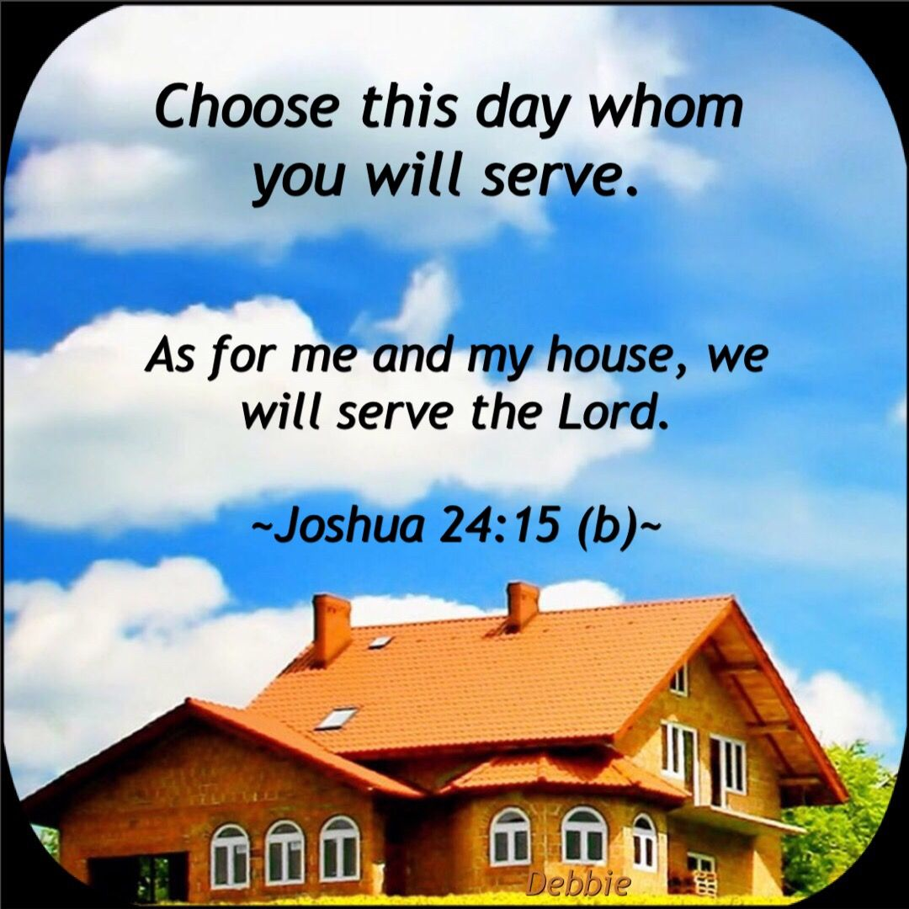
Website: stlukespickwickwels.com / Email: stlukespickwick@outlook.com
Welcome Guests!
Thank you for joining us! We are gathered here to be strengthened in the faith through the Word of Jesus, the Son of God, who has come to forgive and save us all. If there is anything we can do to better serve you, please let us know.
Pastor Steven Neumann’s Contact Info Lead Musicians
Cell Phone #: (262) 308-7666 Connie Hagedorn
Email: pastorsneumann@outlook.com Kris Swogger

Note: We will be celebrating the Lord’s Supper today. As Scripture teaches, our church body believes that communion is an expression of common faith & fellowship between everyone who communes. Therefore, we ask that only those who are already members of the WELS or ELS come forward for communion today. If you would like to know more about becoming a member of the WELS, please speak with Pastor Neumann before or after the service. Thank you.
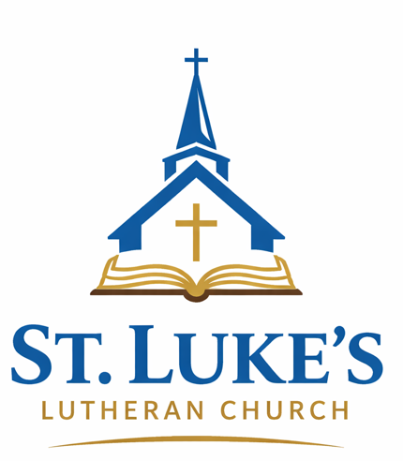



17th Sunday after Pentecost
Theme: There is a Time for Everything: A Time to Prioritize!

Opening Hymn: #459, O God, My Faithful God, v. 1-4

(please stand)
INVOCATION
(The name of the triune God and the sign of the cross remind worshipers of their baptisms.)

M: In the name of the Father and of the Son (+) and of the Holy Spirit.
C: Amen.
CONFESSION
M: Dear friends, let us approach God with a true heart and confess our sins, asking him in the name of our Lord Jesus Christ to forgive us.
C: Lord of life, I confess that I am by nature dead in sin. For faithless worrying and selfish pride, For sins of habit and sins of choice, For the evil I have done and the good I have failed to do, You should cast me away from your presence forever. O Lord, I am sorry for my sins. Forgive me, for Jesus’ sake.
ABSOLUTION
(The use of the keys is that special power and right which Christ gave to his church on earth: to forgive the sins of penitent sinners” [The Small Catechism, First: What is the use of the keys?]. See John 20:21-23.)

M: Christ has died. Christ is risen. Christ will come again. In his great mercy, God made us alive in Christ even when we were dead in our sins. Hear the word of Christ through his called servant: I forgive you all your sins in the name of the Father and of the Son (+) and of the Holy Spirit. / C: Amen.

LORD, HAVE MERCY / Kyrie (Mark 10:47)
(Kyrie is the Greek word for Lord. The expression “Lord, have mercy” is one of the oldest worship responses in the Christian church.)

M: In peace, let us pray to the Lord. For the well-being of all people everywhere, that they may receive from you all they need to sustain body and life, hear our prayer, O Lord. / C: Lord, have mercy.

M: For the spread of your life-giving gospel throughout the world, that all who are lost in sin may be brought to faith in you, hear our prayer, O Christ.
C: Christ, have mercy.

M: For patience and perseverance in this life, that we may not lose the hope of heaven as we await your return, hear our prayer, O Lord.
C: Christ, have mercy.

M: Lord of life, live in us that we may live for you. / C: Amen.

GLORY BE TO GOD / Gloria in Excelsis (Luke 2:14)
(Christians praise God by proclaiming the great things he has done to accomplish our rescue from sin. “Glory to God in the Highest” has been a Christian song of worship since the fourth century.)

1. All glory be to God on high! Your name, O Lord, we glorify;
We praise you for your peace and grace, Your favor toward our fallen race.

2. Our grateful thanks to you we bring, For your great glory, heav’nly King,
For all, O Father, you have done Through Jesus Christ, your only Son.

3. O Lamb of God, to you we pray. You take all human sin away.
Have mercy, Lord; receive our prayer; From God’s right hand, your mercy share.

4. You, Christ, are holy—Lord alone; The Father’s glory you made known.
We by your Spirit sing again: “All glory be to God!” Amen.

+ THE WORD OF THE DAY +

SALUTATION
(This greeting has deep roots in Christian worship and marks the beginning of the Word section and the Sacrament section of the service.)

M: The Lord be with you. / C: And also with you.

PRAYER OF THE DAY
M: Let us pray. / Lord God, you call us to work in your kingdom and promise to reward us according to your grace. Help us to rid our minds of worldly expectations and rejoice that you freely pour out the blessings of salvation to all people; through the merits of Jesus Christ our Lord, who lives and reigns with you and the Holy Spirit, one God, now & forever. / C: Amen.

FIRST LESSON: Joshua 24:14-24 (sermon text) “Now fear the Lord and serve him with all faithfulness. Throw away the gods your ancestors worshiped beyond the Euphrates River and in Egypt, and serve the Lord. But if serving the Lord seems undesirable to you, then choose for yourselves this day whom you will serve, whether the gods your ancestors served beyond the Euphrates, or the gods of the Amorites, in whose land you are living. But as for me and my household, we will serve the Lord.” Then the people answered, “Far be it from us to forsake the Lord to serve other gods! It was the Lord our God himself who brought us and our parents up out of Egypt, from that land of slavery, and performed those great signs before our eyes. He protected us on our entire journey and among all the nations through which we traveled. And the Lord drove out before us all the nations, including the Amorites, who lived in the land. We too will serve the Lord, because he is our God.” Joshua said to the people, “You are not able to serve the Lord. He is a holy God; he is a jealous God. He will not forgive your rebellion and your sins. If you forsake the Lord and serve foreign gods, he will turn and bring disaster on you & make an end of you, after he has been good to you.” But the people said to Joshua, “No! We will serve the Lord.” Then Joshua said, “You are witnesses against yourselves that you have chosen to serve the Lord.” “Yes, we are witnesses,” they replied. “Now then,” said Joshua, “throw away the foreign gods that are among you and yield your hearts to the Lord, the God of Israel.” And the people said to Joshua, “We will serve the Lord our God and obey him.” (NIV)

PSALM OF THE DAY - We join to sing Psalm 111 Sing to the Lord a new song (found on page 106 at the front of our red hymnal, Christian Worship).
SECOND LESSON: Ephesians 5:15-20 Be very careful, then, how you live— not as unwise but as wise, making the most of every opportunity, because the days are evil. Therefore, do not be foolish, but understand what the Lord’s will is. Do not get drunk on wine, which leads to debauchery. Instead, be filled with the Spirit, speaking to one another with psalms, hymns, and songs from the Spirit. Sing and make music from your heart to the Lord, always giving thanks to God the Father for everything, in the name of our Lord Jesus Christ. (NIV) / (please stand)

GOSPEL ACCLAMATION
M: Alleluia. Seek first His Kingdom and His righteousness, and all these things will be given to you as well. Alleluia. (Matthew 6:33)
C (♫): Alleluia! Alleluia! Faith comes from hearing the message, and the message is heard through the Word of Christ. Alleluia! Alleluia!

GOSPEL: M: The Gospel according to Matthew chapter 6 / C: Glory be to you, O Lord.
(Jesus said:) “Therefore, I tell you, do not worry about your life, what you will eat or drink; or about your body, what you will wear. Is not life more than food, and the body more than clothes? Look at the birds of the air; they do not sow or reap or store away in barns, and yet your heavenly Father feeds them. Are you not much more valuable than they? Can any one of you, by worrying, add a single hour to your life? “And why do you worry about clothes? See how the flowers of the field grow. They do not labor or spin. Yet I tell you that not even Solomon in all his splendor was dressed like one of these. If that is how God clothes the grass of the field, which is here today and tomorrow is thrown into the fire, will he not much more clothe you—you of little faith? So do not worry, saying, ‘What shall we eat?’ or ‘What shall we drink?’ or ‘What shall we wear?’ For the pagans run after all these things, and your heavenly Father knows that you need them. But seek first his kingdom and his righteousness, and all these things will be given to you as well. Therefore, do not worry about tomorrow, for tomorrow will worry about itself. Each day has enough trouble of its own.” (NIV) M: This is the Gospel of the Lord. / C: Praise be to you, O Christ.

HYMN OF THE DAY: #395 Seek Where You May to Find a Way, v. 1-4
SERMON by Pastor Neumann on Joshua 24:14-24
It’s a NO-Brainer!

NICENE CREED
(Public confession is faith’s response to God’s saving Word. Christians composed the Nicene Creed in the 4th century to defend the Bible’s teachings that both Jesus Christ and the Holy Spirit are true God, equal to the Father in one eternal, undivided Trinity.)

We believe in one God, the Father, the Almighty, Maker of Heaven and Earth, of all that is, seen and unseen.

We believe in one Lord, Jesus Christ, the only Son of God, eternally begotten of the Father, God from God, Light from Light, true God from true God, begotten, not made, of one being with the Father. Through him all things were made. For us and for our salvation, he came down from heaven, was incarnate of the Holy Spirit and the virgin Mary, and became fully human. For our sake he was crucified under Pontius Pilate. He suffered death and was buried. On the third day he rose again in accordance with the Scriptures. He ascended into heaven and is seated at the right hand of the Father. He will come again in glory to judge the living and the dead, and his kingdom will have no end.

We believe in the Holy Spirit, the Lord, the giver of life, who proceeds from the Father and the Son, who in unity with the Father and the Son is worshiped and glorified, who has spoken through the prophets. We believe in one holy Christian and apostolic Church. We acknowledge one baptism for the forgiveness of sins. We look for the resurrection of the dead and the life of the world to come. Amen.

OFFERING
(Moved by God’s love in Christ, we offer him our first and best gifts, purely out of thanks to him.)
Visitors: We are very glad you are worshiping with us today. Please don’t feel obligated to give an offering. ALL: Please greet and introduce yourself to those around you.

PRAYER OF THE CHURCH
By pastor
+ THE SACRAMENT +

PREFACE
(The words of the Preface mark the beginning of the Sacrament section of the service and lift the worshipers’ hearts in praise. The opening sentences are among the oldest in the Christian liturgy.)

M: The Lord be with you. / C: And also with you.

M: Lift up your hearts. / C: We lift them up to the Lord.

M: Let us give thanks to the Lord our God.
C: It is good and right so to do.

M: It is truly good and right that we should at all times and in all places give you thanks, O Lord, holy Father, almighty and everlasting God, through Jesus Christ, our Lord, who has called us to be his own so that we may live under him in his kingdom and serve him in everlasting righteousness, innocence, and blessedness. Therefore with all the saints on earth and hosts of heaven, we praise your holy name and join their glorious song:
HOLY, HOLY, HOLY / Sanctus (Isaiah 6:3; Matthew 21:9)
(Sanctus means “holy.” Used possibly as early as the second century, this canticle was in wide use among Christians in worship by the fourteenth century.)

- O holy, holy, holy Lord God of pow’r and might,
Your glory, earth and heaven In countless ways recite.
Hosanna! Come and save us, Lord God of hosts on high,
And in your grace and mercy Receive our fervent cry.

2. Hosanna in the highest! How truly blest is he
Who in God’s name is coming To set his people free!
He comes to bring salvation And with his blood outpoured,
Deliver us from bondage—Hosanna, mighty Lord!

PRAYER OF THANKSGIVING
(Jesus took bread and gave thanks [Matthew 26:26].)

M: Blessed are you, O Lord of heaven and earth. We praise and thank you for sending your Son, Jesus Christ, and we remember the great acts of love through which he has ransomed us from sin, death, and the devil’s power. By his incarnation, he became one with us. By his perfect life, he fulfilled your holy will. By his innocent death, he overcame hell. By his rising from the grave, he opened heaven. Invited by your grace and instructed by your Word, we approach your table with repentant and joyful hearts. Strengthen us through Christ’s body and blood and preserve us in the true faith until we feast with him and all his ransomed people in glory everlasting. / C: Amen.
LORD’S PRAYER (Matthew 6:9-13)
Our Father, who art in heaven, hallowed be thy name, thy kingdom come, thy will be done on earth as it is in heaven. Give us this day our daily bread; and forgive us our trespasses, as we forgive those who trespass against us; and lead us not into temptation, but deliver us from evil. For thine is the kingdom, and the power, and the glory, forever and ever. Amen.

[Video Service Ends – Minister shares blessing with online viewers.]

WORDS OF INSTITUTION (Matthew 26:26-28, 1 Corinthians 11:24,25)
(As he speaks the Words of Institution, the minister both proclaims the words of Jesus to the congregation and sets apart the bread and wine for the Lord’s use. The sign of the cross reminds us of Christ's death.)
M: Our Lord Jesus Christ, on the night he was betrayed, took bread, & when he had given thanks, he broke it and gave it to his disciples, saying, “Take and eat; this is my body, which is given for you. Do this in remembrance of me.” / Then he took the cup, gave thanks, and gave it to them, saying, “Drink from it, all of you; this is my blood of the new covenant, which is poured out for you for the forgiveness of sins. Do this, whenever you drink it, in remembrance of me.” / M: The peace of the Lord be with you always. / C: Amen.

LAMB OF GOD / Agnus Dei (John 1:29)
(Jesus is God’s Lamb [Agnus Dei], who was offered as a sacrifice for sin once for all.)

C(♫): Lamb of God, you take away the sin of the world; have mercy on us.
Lamb of God, you take away the sin of the world; have mercy on us.
Lamb of God, you take away the sin of the world; grant us your peace. Amen.
DISTRIBUTION
(The Scriptures teach that the celebration of the Lord’s Supper connects us intimately with Christ and with one another as Christians who are united around a common confession of faith.)

+ Distribution +
Distribution Hymns: #376 Jesus,, Your Blood and Righteousness, v. 1-6
#383 Blessed Are They, Forever Blest, v. 1-4

SONG OF SIMEON / Nunc Dimittis ( Luke 2:29-32)
(The Nunc Dimittis [“Now dismiss”] is also known as the “Song of Simeon.” Through God’s Word & Sacrament, we have seen Jesus Christ, and like Simeon we find divine peace and comfort through faith in the Savior.)

- O Lord, now let your servant Depart in peace, assured:
For I have seen your promised Incarnate, saving Word—
A Light that will enlighten All gloom where Gentiles dwell;
The brilliant, crowning glory Of those in Israel!

- All glory to the Father, All glory to the Son,
All glory to the Spirit, Forever three in one;
For as in the beginning, Is now, shall ever be,
God’s triune name resounding Through all eternity.

M: We give you thanks, O Lord, for the foretaste of the heavenly banquet that you have given us to eat and to drink in this sacrament. Through this gift you have fed our faith, nourished our hope, and strengthened our love. By your Spirit help us to live as your holy people until that day when you will receive us as your guests at the wedding supper of the Lamb, who lives and reigns with you and the Holy Spirit, one God, now and forever. / C: Amen.

BLESSING (Numbers 6:24-26)
(The blessing of Aaron has been spoken over God’s people for over 3,500 years. The Lord said, “So they will put my name on [them], and I will bless them” [Numbers 6:27].)

M: The Lord bless you and keep you. The Lord make his face shine on you and be gracious to you. The Lord look on you with favor and (+) give you peace.
C: Amen.
© 2008 Northwestern Publishing House. All rights reserved. Used by permission.

Closing Hymn: #765 Day by Day (from the BLUE Supplement), v. 1-3

-----------------------------------------------------------------------------------------------------------------
Today’s Door Offering: Lutheran Women’s Missionary Society (LWMS) – The Church Council approved giving our door offering for the 1st 3 Sundays in September & the 1st Sunday of October to the LWMS Fall Mission Projects: WELS Campus Ministry & the WELS World Missions International Wives’ Conference.

Bible Study: Join us downstairs after the service as we continue to delve into our Sunday AM Bible study on 1 Corinthians & learn from ‘A Congregation in Crisis’. Coffee & goodies to get you through until lunch will be provided.

Happy Birthday: Rob Betsinger (Today!), Jim Larsen, Denise Albrecht (21st), Vic Gardner, Michael Camp (22nd), Bud Krause (26th). / Happy Anniversary: Scott & Barb Fabian (21st).

This Week at St. Luke’s
TODAY: La Cresent Apple Fest Parade, 1 PM.
Monday: Women’s Fall Bible Study, 6:30 PM.
Tuesday: Women’s Bible Study 9:30AM (every other week) Albrecht’s (26229
Little Trout Valley Rd.)
Wednesday: Bible Study 6:30 PM; Book is “Connecting Sinai to Calvary”
Thursday: Worship Service at 6:30 PM.
September Cleaning: Kris Swogger by 9/20; Jess McCann by 9/27/2026.
September Ushers: Scott Fabian, Wayne Albrecht, & Kurt Swogger.
Sept. Bulletin Sponsors: Marvin & Mary Jo Mades celebrating their 47th Anniversary; Denny & Debi Allen and Bill & Tara Suffrins in memory or Dean Suffrins’ Birthday.

Looking Ahead:
Mission Festival: A special 9am Mission Service will be held on Sunday, September 27th with lunch afterwards. Pastor Mark Wegner of WELS 316NOW (mission work in SE Asia) will preach and present. Make plans to join us for this special day and bring a friend! See sign-up sheets in the entry for food & help for this celebration. The Door Offering this day will go to support WELS mission work through 316NOW.

Family Bible Study: Join us on Wednesday September 30th at 6pm for this fun evening of food, fellowship, and having our faith fed! This less formal bible study takes place at Kurt and Kris Swogger’s home (23371 Lamoille Rd). We begin with a meal together (a main dish is provided – please bring a dish to share if possible); then after supper, we do our bible study: Idols We Never Knew We Had. The fall session meets 4 times every other Wednesday starting September 30th. We’d love to have you join the fun!

Get Moving Women’s Event: Ladies, do you struggle with grief, shame, hurt, or overwhelming dread? As you look to the future do you feel like whatever is ahead is too much? Join us October 3rd as Amber Albee Swenson takes us into Scripture to explore what’s holding you back & to equip you to bravely ‘get moving’ into tomorrow. Find out more information and register at: amberalbeeswenson.com.

LWMS Fall Rally: will be held on Saturday, October 17th (9AM – Noon) at First Lutheran in La Cresent; registration starts at 8:00AM. Lunch & Fellowship to follow. Guest Speaker will be Rev. Larry Schlomer, Board of World Missions, Administrator. Theme: What in the World is WELS Doing? There is a challenge to double our attendance from the Spring Rally. Women & Men are welcome to attend and Childcare will be available. Natalie Siok is POC for questions.

WELS Military Retreat: will be held October 8-11 at Ironwood Springs Christian Ranch near Rochester, MN. This event is for active military members & veterans, and their spouses. Learn more or register at www.lutheranmilitary.org.

Men of His Word Conference: Gentlemen, want to be involved in lively worship, be encouraged in living your life as a Christian man in all of your vocational callings, and do so with brothers in the faith? Come to the Men of His Word Conference (WELS) in Rochester MN on Saturday, October 24th. To encourage our men to attend, our church council approved covering the cost for any man from St. Luke’s who wants to go. If you are interested speak with Tom Mueller ASAP.

Living Nativity Support: From Thanksgiving weekend through December, the WELS churches of this area, St. Luke’s included, help support a Living Nativity in Riverside Park in La Crosse. Any member of our church is welcome to support this endeavor by being in the show, working behind the scenes, or the like. But this year, our church is up to provide the main dish for the volunteers on the weekend of Thanksgiving. If you’d be willing to coordinate a main dish for 25-30 people sharing the love of Jesus like this, or if you’d like to volunteer, please speak with Tom Mueller, our church’s liaison.

St. Lukes Ev. Lutheran Church (WELS), Pickwick MN

Service Times: Thursdays: 6:30PM Sundays: 9AM with Bible Study at 10:15AM
Communion is normally celebrated the 1st & 3rd weeks of the month

Church (507) 454-1380 Parsonage (262) 652-7215
24799 Trout Street 39246 Mill Street
Winona, MN 55987 Winona, MN 55987

If you EVER have a question/concern, speak with any of St. Luke’s Leaders:

St. Luke’s Church Council Members
Mark Wieser, President (2nd Term – 2027), markwieser85@gmail.com , 507-312-0085
Jim Albrecht, Financial Secretary (1st Term – 2027), ltcattle@acegroup.cc , 507-643-6126
Jeremy Church, Treasurer (2nd Term – 2028), jeremych87@gmail.com , 507-459-0648
Tom Mueller, Secretary (1st Term – 2029), tpmue@yahoo.com , 507-452-5539
Kurt Swogger, Properties (2nd Term – 2028), kurtswog@yahoo.com , 507-313-0013
Dean Morgan, Properties (1st Term – 2029), deanm@hbci.com , 507-450-3663
Elders:
Tim Albrecht (talbrech@acegroup.cc /507.459.2722), - Alex Ellinghuyusen (are1976@gmail.com / 507.429.0321), - Scott Fabian (scottfabian21@gmail.com /507.458.2442), & Bud Krause (lckjak1@gmail.com / 507.454.6938)
In Our Entryway, please help yourself to:
Keurig Coffee, Cider, and Hot Chocolate, as well as Church Calendars for the month,
Meditations (devotional book), & “Forward in Christ” & MLC’s “In Focus” Magazines.

St. Luke’s Lutheran Church of Pickwick, MN:
• is a gathering of Christians that exists to teach and preach the Word of God in all its truth & purity here among us and to all the people of earth.
• accepts the Bible as the inspired & inerrant Word of God.
• accepts the Unaltered Augsburg Confession as a correct confession of Biblical faith.
• believes that God created the entire universe in six natural days out of nothing but his almighty Word.
• believes that humankind fell into sin and is totally corrupt, dead in trespasses and sin, and doomed to hell.
• believes that God in undeserved love sent his own Son, Jesus, who took on humanity, lived a perfect life in our place, and suffered death and damnation for us and all our sins.
• believes that God the Holy Spirit uses this Gospel message in Word and Sacraments to create faith in us thereby making Jesus’ saving work ours.
• has as its goal to worship & serve God in thanksgiving, and to serve our neighbor in love as Jesus calls us to.

If you or someone you know might be interested in learning more about the Christian Faith or in joining our congregation, Pastor offers a NO COST / NO OBLIGATION Bible class that goes over the main doctrines of the Christian faith. This class also serves as the needed Preparation to take the Lord’s Supper at St. Luke’s, if the person is so interested. This class is scheduled on a day and time that works best for those who are interested in taking it. Speak with Pastor for more information and specifics.


